Week 1 (9/25 - 9/29):
Week 2 (10/2- 10/6):
Week 3 (10/9- 10/13):
Week 4 (10/16- 10/20):
Week 5 (10/23- 10/27):
Week 6 (10/30- 11/3):
Week 7 (11/6- 11/10):
Week 8 (11/13- 11/17):
Week 9 (11/20- 11/24):
Week 10 (11/27- 12/1):
Week 11 (12/4- 12/8):
Week 12 (12/11- 12/15):
Week 13 (12/18- 12/22):

Week 1 (9/25 - 9/29):
Balloon and money are biggest priorities
- Funding
  - Leftover from 2022/23 grants: ~$7,500
  - JAC (provides minimal funding)
    - Deadline Mid October
  - Alumni
    - Make an info pack
    - Deadline Mid October
- Short term goals
  - Satellite subgroup
    - Create chart of materials for payload
      - Look @ Actual Satellite Section
    - Merit Review( late november/ early december)
      - Before we get merit review, we need to do the weather balloon
  - Lead
      - Mission: NASA explores the unknown in air and space, innovates for the benefit of humanity, and inspires the world through discovery
      - Learning agenda
      - Objectives 2022:
        - DISCOVER
          - Earth & climate, Sun, Solar system, universe
        - EXPLORE
          - Surface of the moon/ deep space
          - Research to safeguard explorers
        - INNOVATE
          - Efficient and sustainable aviation
          - Innovate and advance space technology
        - ADVANCE
          - Develop a workforce
          - Transform mission support in aero
          - Next gen of explorers
  - Ideas to fit into objective
    - Make the mission dual purpose: Analyze the behavior of the properties in a space environment/ how does the reflective ability impact space travel. What are other options for thermal whatever
- Long term goals
  - Apply to CSLI by 2024
- CSLI Prep
  - UNP Program
    - https://www.nasa.gov/sites/default/files/atoms/files/nasa_unp_fliers_2a.pdf
- Actual Satellite:
  - payload, pycubed (only open source satellite purpose) or raspberry pi , epaper (talk to suppliers), wide angle camera, comms(talk to jay),
  - Satellite Design:open source satellite design uHawaii maui cal Pomona
  - Lithium ion battery
  - Aluminum frame (cnc machine)
- Balloon Options:
  - Columbia weather balloon program
    - 50/50 chance, they r lowkey having leadership problems
  - NASA flight opportunity
  - Balloon company in BK
  - Senior Project working on a rocket (it will prob blow up)

DUAL PURPOSE CUBESAT:
- Explore: explore the thermal conductivity properties of e paper in relation to
- Innovation: Introduce the first near earth gallery to near earth; entrepreneurship opportunities

Week 2 (10/2- 10/6):
- Ground Station:
- Building an actual ground station
  - ability to hold the antenna, move it around
  - Speed for moving antenna, housing the electronics, waterproofing, we dont want it to tip over
  - Get input from EEs, what do we actually need
  - GOAL: finish ground station by end of semester
    - On the MechE side: housing the station
On the EE side: circuits, antenna, comms

- Payload:
  - What are we actually DOING with the satellite? HOW do we accomplish this with sensors?
    - List function of payload: what does it need to do and how will we measure this?
  - Developing an experimental protocol (see block diagram)
  - Completing the experiment on the bench
    - Start in B/W, change pixel density, explore the greyscale.
  - Things to consider:
    - Reflecting heat vs absorbing heat
    - How do we heat the paper on the bench?
    - How do we measure the heat gradient? Thermal camera vs sensors (ie thermistors and thermocouples)
    - How accurate is this gradient? How consistent is our data?
- Right now, the actual satellite is an afterthought to our ability to replicate its purpose in a lab
- Reflecting vs absorbing
- Consistent readings
- Experimental protocol:
  - Start in BW, change on greyscale.
  - Thermistor; accuracy of sensors, where do they go inside the frame
    - Maybe look into thermal cameras instead.
  - Prove that it works on benchtop via these experiments
- Brandon Bunt heat transfer through mycelium

Week 3 (10/9- 10/13):
- Possible Experimentation:
  - Square UV lamp, thermal camera, vacuum chamber.
    - Measure surface temperature
    - Constant T in chamber, vary screen, collect gradient over time.
- Check out the LHCM

Week 4 (10/16- 10/20):

Week 5 (10/23- 10/27):

Week 6 (10/30- 11/3):
- Current experiment setup, subject to change in future.
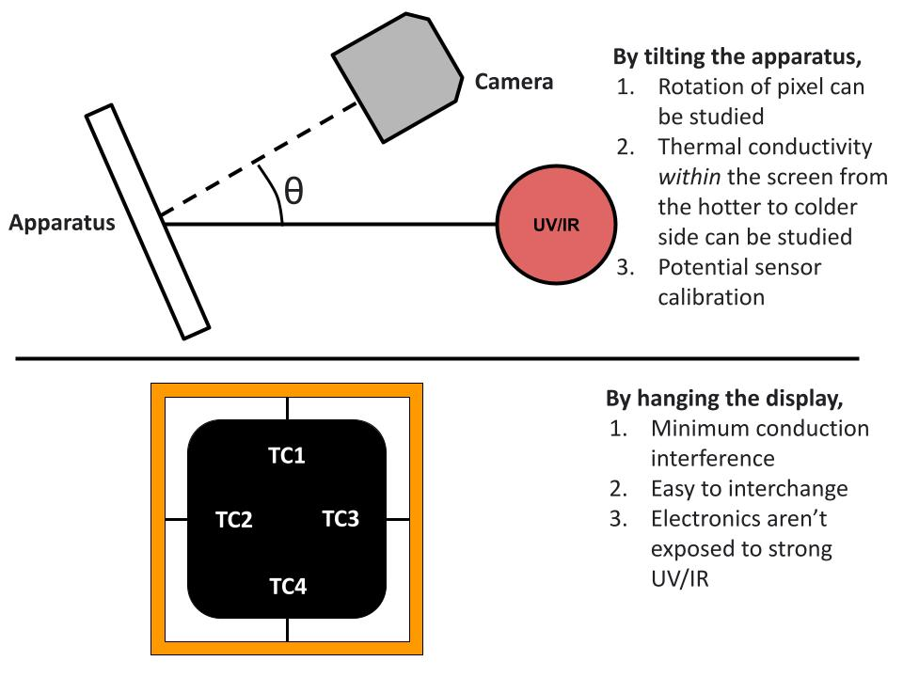

Week 7 (11/6- 11/10):

- Link to purchase sheet: https://docs.google.com/spreadsheets/d/1vHxzNZ8rWxmt0A2S5K7hbbTR5kD1SfEWF2ovofoADOk/edit?usp=sharing

Week 8 (11/13- 11/17):
- Did not meet.

Week 9 (11/20- 11/24):
- Payload:
  - Began working with the e-paper (interfacing, coding specific outcomes, etc)
    - NOTE: this needs a lot of work
- Outreach:
  - New Poster!
  - New members?
- Comms:
  - Developed Ground Station Spec Sheet
    - https://drive.google.com/file/d/1A5c-0cAV2kDZdjXQ4TAhV-reaqYOlbAu/view?usp=sharing

Week 10 (11/27- 12/1):
- Discussed potentially submitting abstracts to Small Sat convention/ competition
  - Necessity for proof of concept, start working on experiment asap
  - Need abstract by February 2024.

Week 11 (12/4- 12/8):
- No meeting

Week 12 (12/11- 12/15):
- Developed the semester time frame for spring 2024
  - https://docs.google.com/document/d/16IwzPF2vEAGvDOhSY-f8JJANrS6lPziCtlldUFTRMWM/edit?usp=sharing

Week 13 (12/18- 12/22):
- Meeting w/ Prof Wright, following link is the new master document for the InkSat mission’s payload/ experimentation
  - https://docs.google.com/document/d/1ejWpAx4jv5_viTteakUL055a2MhL-Yi7fZnrsTIXBvE/edit?usp=sharing

